St. John’s - St. Andrew’s
Catholic School
Website:sjsaschool.org

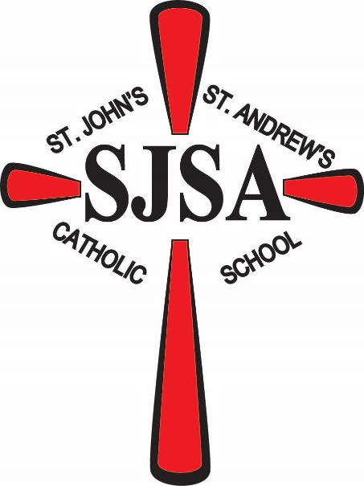

I can do all things through Christ who strengthens me
Philippians 4:13
Parent/Student Handbook
2022-2023

St. John’s - St. Andrew’s
Catholic School
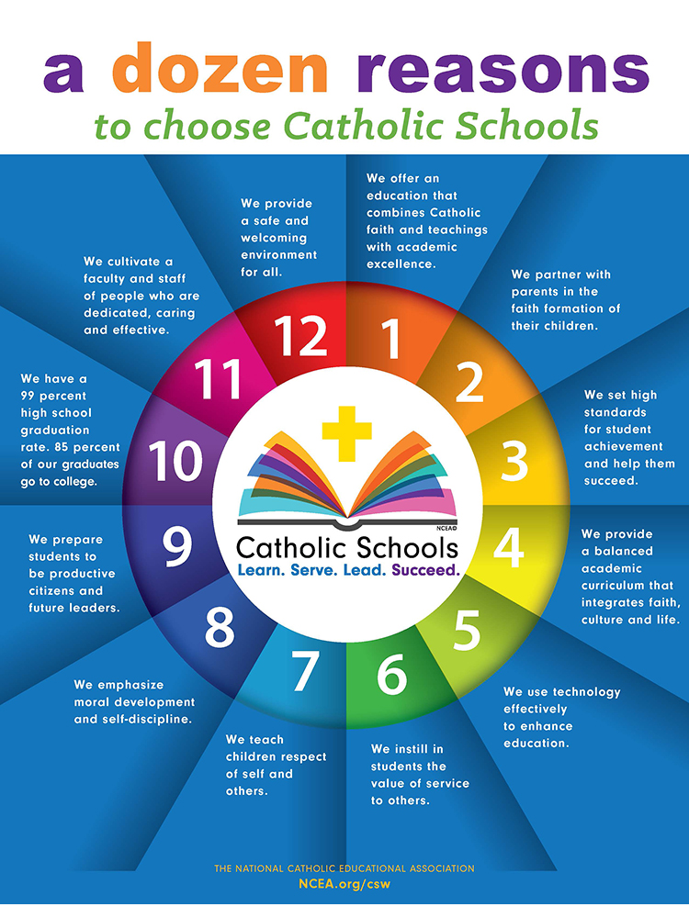
Welcome to the
2022 – 2023
SCHOOL Year!!

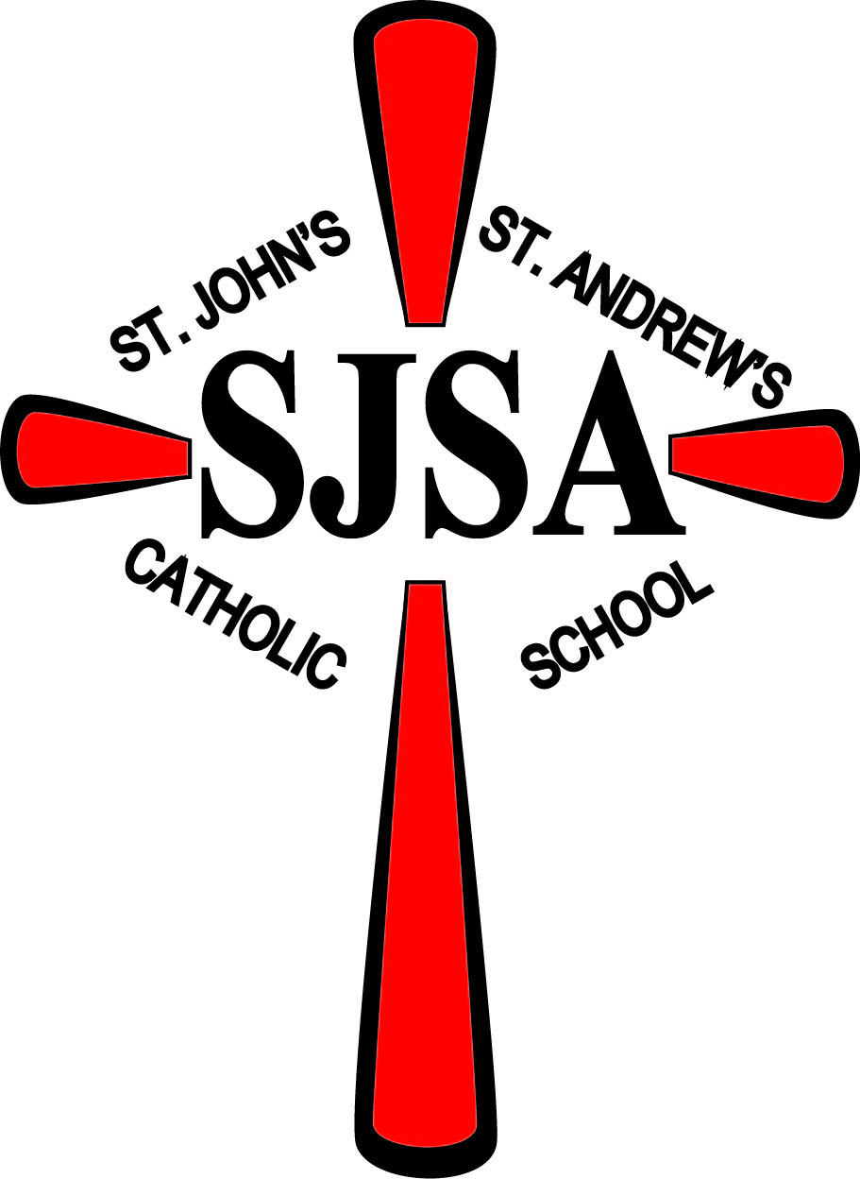

Dear SJSA Families,
Welcome to the 2022-2023 school year at St. John’s – St. Andrew’s Catholic School. The teachers, staff, and volunteers are excited to welcome students back for the upcoming school year.
We are grateful that your family has chosen St. John’s – St. Andrew’s Catholic School. Thank you for your support of your child’s education. The staff is committed to your child’s spiritual and academic growth. We will strive to make Gospel values the center of each school day.
This handbook is designed to answer many of your questions. Please take the time to read through it and familiarize yourself with the school information and policies. We will send home a school newsletter at the beginning of each month with important dates and announcements. Weekly updates/announcements will be sent home or emailed as necessary.
On behalf of Fr. Marv Enneking, Fr. Arockiya Newton, the teachers, staff, and volunteers, we thank you for your prayers and support. Thank you for working with us to carry out the mission of St. John’s – St. Andrew’s Catholic School. Please feel free to call or email me with any questions you might have.
Blessings to you,
Mrs. Mary Miller

St. John’s-St. Andrew’s Catholic School
Parent / Student Handbook

2022-2023
Table of Contents
Letter from the Principal
Mission Statement & Philosophy
St. John’s - St. Andrew’s Catholic School Staff Listing
Board of Education
Concerns Response Procedure for Parents
Admission and Tuition
Daily Schedule
Attendance, Absences, and School Closings
Tardy and Early Dismissal
Student Release
Visitors
Winter Weather Closing
Communications
Newsletter / Family Envelope
Sending Money with Your Child
Progress Reports and Parent/Teacher Conferences
Telephone
Faculty Availability
Directory Information
Student Behavior
General School Rules
Playground Behavior & Rules
Lunch Room Behavior & Rules
Consequences for Breaking Rules/Discipline
School Dress Code
Lost & Found and Peanut Allergy
Hot Lunch Program
General Curriculum
Instructional Materials
Course Offerings
Church Attendance (Mass)
Achievement Tests
Homework
Guidelines for Internet Use
Special Services
Counseling Services
Title 1 Services
Special Education Services
Speech Services

Volunteers
Foster Grandparents
Transportation
Bus Transportation
Bus Ridership and Evacuation Drills
Field Trips
Photo Release
Health & Safety
Emergency Sheet
Health Services
Medication Policy
Immunizations
“Zero Tolerance”
Weapons
Drug Free School
1995 MN Crime Bill
Sexual/Gender/Racial Harassment
Child Abuse Reporting
Safe Environment Directive
AHERA – Asbestos Hazard Emergency Response Act
Pesticide Use
Minnesota Hazard Communication: What you need to know
Emergency Safety Procedures
Crisis Management Plan
Fire Drills
Tornado Drills
Building Lockdown Drills
How you can make a difference at SJSA

Mission Statement

St. John’s - St. Andrew’s School is dedicated
to providing
a Christian learning environment
which will foster
the growth and development
of each child.

St. John’s - St. Andrew’s School Philosophy

St. John’s - St. Andrew’s Catholic School is a place of spiritual and academic growth for students, staff, parents, and parish community.
We strive
to educate students by fostering Christian values
promoting a feeling of security and self - worth,
and meeting individual needs
through a comprehensive program.
We provide
a variety of opportunities to learn basic academic skills,
while helping each student accept responsibility
for his/her own learning.
We emphasize
respect for oneself,
respect for other people,
and for all forms of life and the environment that
sustains them.
We nurture a community of lifelong and compassionate learners
Through Catholic values
and follow Jesus’ example through
prayer, service, and love.

SJSA is a peanut free school!

Staff
St. John’s - St. Andrew’s
Catholic School

School Phone: 987- 3133

Second line: 987-3491

School email: stjohnstandrew@gmail.com

Website: sjsaschool.org
Our school website is full of useful information about our school, upcoming events, school & lunch calendars & much more.

Facebook: St. John’s – St. Andrew’s School

Tri-Parish Office: 987- 3205

Melrose Parish Office: 265-4207

Pastor: Father Marvin Enneking, 320-256-3108

Parochial Vicar: Father Arockiya Newton 320-256-3108

Deacon: Deacon Ernest Kociemba email: ewkociemba@stmarysofmelrose.com

Principal: Mrs. Mary Miller email: sjsamarym@gmail.com

Administrative Assistant: Mrs. Kristen Pattinson email: sjsakristenu@gmail.com

Teachers:

Pre-K & Kindergarten: Ms. Hope Schreifels email: sjsaschreifelsh@gmail.com

Grades 1 & 2: Mr. Kevin Hoisington email: sjsahoisington@gmail.com

Grades 3 & 4: Ms.Katelyn Groetsch email: sjsakatelyng@gmail.com

Grades 5 & 6: Mrs. Kari Kasper email: sjsakasperk@gmail.com

Music: Ms. Emily Krogstad email: ekrogstad@isd740.org

Art: Mrs. Carrie Schulzetenberg email: cschulzetenberg@isd740.org

Phy. Ed: Mrs. Katie Meyer email: kmeyer@isd740.org

Bookkeeper: Mrs. Brenda Nathe email: jenathe@meltel.net

Foster Grandparent: Mrs. Jane Welle

Volunteers: Mrs. Joyce Schoenberg , Mrs. Joni VanBeck & Sister Suzanne Slominski

Title 1: Amy Notch 256-3617

Speech: Alissa Taffe 256-3617 ext. 3219

Public School Nurse: Jackie Hellermann 256-3617 ext. 1020

Public School Counselor: Jenny Nietfeld (in an Emergency only) 256-3617 Ext. 3400

District Information

Kraemer Bus 987 - 3325

Melrose Elementary 256 - 3617

Melrose Senior High School 256 - 4224

Grounds Keeper: Harold Rademacher

Board of Education

Education is one of the most important means by which the mission of Christ is fulfilled. The Board of Education has been established to oversee educational programs at St. John’s - St. Andrew’s School, to determine, interpret, and implement policies relating to the planning, operating and maintenance of the facility and equipment, and to create better understanding and support of Catholic education.
The Board is composed of seven elected members and the pastor. The principal is an ex-officio, non-voting member. Nominations for new members shall take place in April, elections will be held in May. Terms run for three years and shall expire June 30th of each year.
The Board of Education meetings are held the third Tuesday of the month, unless otherwise notified, beginning at 7:30 p.m. These are OPEN MEETINGS and everyone is welcome. To be on the agenda let the Principal/Chairperson know a week before the scheduled meeting.
Ex-Officio Members:
Father Marvin Enneking 256-4207 (Melrose parish office)
Father Arockiya Newton 256-4207 (Melrose parish office)
Mary Miller 320-250-4411
Official Members:
St. John’s --Meire Grove St. Andrew’s -- Greenwald
Janice Funk Kathy Gilk 33025 Overton Road 33204 Overton Rd.
Melrose MN 56352 Melrose, MN 56352
(320 987-3219 (320) 987-2873
jfunk@meltel.net skgilk@meltel.net

Kurt Meyer Bridget Kasper
175 Meyer Dr. 39510 Piper Lane
Melrose, MN 56352 Sauk Centre, MN 56378
(320) 987-4896 (761) 238-6534
kurtm@mycmcu.org kasperfarms@yahoo.com

Kate Kelzer Trista Roelike
38779 Co. Rd. 191 30166 Co. Rd. 175
Sauk Centre, MN 56378 Melrose, MN 56352
(320) 293-2606 (320) 987-293-4659
kakelz86@gmail.com ptroelike@hotmail.com

School Board Member at Large
Kristi Zimmer
36213 Co. Rd. 13
Melrose, MN 56352
320-249-6702
jk_zimmer@live.com

Concerns Response Procedure for Parents

Should a question arise concerning your child, parents are recommended to first contact the classroom teacher to openly discuss any concerns that you may have. St. John’s – St. Andrew’s Catholic School teachers are certified, licensed professionals who are open to parental input, and who will not treat your child any differently in response to your contact of them. A large majority of all parental concerns can and will be settled quickly and easily by open, supportive communication between parent and teacher. However, in the event that open communication between parent and teacher is unsatisfactory, communications should then be directed to the principal. As a third party in any situation, the principal will work to mediate any situation in the best interest of all parties. If open communication between the parent and principal is also deemed unsatisfactory, that person may then attempt to resolve their issue by addressing the Pastor or School Board of Education. A process to gather information will begin, and corrective action will be taken if the situation warrants.

Admission and Tuition
Admission Policy
St. John’s – St. Andrew’s Catholic School, compelled by Gospel values and the teaching mission of the Church, extends an invitation to students regardless of their race, gender or national origin. A disability, either temporary or permanent, is not a disqualification of admission, providing that with reasonable accommodation the disabled person can function in the school environment. Determination as to the suitability of St. John’s – St. Andrew’s School to meet the extraordinary needs of the student will be made prior to formal admission of students with extraordinary needs.

Tuition
The Tuition at St. John’s - St. Andrew’s Catholic School is as follows:
Grades 1-6:
1st child $1750.00 $194.44 a month
2nd child $1450.00 $161.11 a month
3rd child $1100.00 $122.22 a month
4th child $875.00 $97.22 a month
Kindergarten $1100.00 $122.22 a month
Pre-K $850.00 $94.44 a month

St. John’s – St. Andrew’s Catholic School receives very minimal federal and state funding and relies heavily upon the financial support of parental tuition, subsidy from the St. John the Baptist, St. Andrew’s and St. Michael’s parishes, and fundraisers to maintain operating costs and budgetary expenses. St. John’s – St. Andrew’s believes in quality Catholic education for all children and wants to afford the opportunity of Catholic education to all families who desire it. However, all families must share in the responsibility for this service. Payment of your tuition commitment is your responsibility to our school family and must be given a high priority in family budgetary plans. (Financial assistance is available if needed. Please talk to the principal for more information.)

Families who are registered members of Catholic parishes receive substantial assistance to attend the school, as parish financial support subsidizes some of the difference between tuition costs and the actual education costs. As a clarification, a registered parish member is not simply one who is enrolled in a parish, but someone who regularly attends Mass, church functions, and supports the parish through time, talent, and treasure.

There are several tuition payment options from which to choose:
- Annual – Payment of tuition for the upcoming school year.
- Semi-annual – Two payments, one at the beginning of the year and the second payment due at the beginning of the Second Semester (January)
- Quarterly – Four payments received at the beginning of each quarter; September, November, January, and March.
- Monthly – Nine payments during each month of the school year.

Please send a separate check for tuition payment in a sealed envelope marked Principal / tuition. We will send a monthly statement in the parent envelope as we have done previously.

If parents/guardians anticipate that they will not be able to make a tuition payment on time, they are asked to contact the principal.

Students who are not Catholic and attending St. John’s - St. Andrew’s Catholic School are expected to attend Mass and be respectful of the Church’s practices. Students are expected to participate in religion class and daily prayers.

Daily Schedule
7:45 Students in classrooms
8:00 School Begins
11:30 – 12:00 Lunch
12:00 – 12:30 Recess
2:25 Prayer
2:30 Dismissal and Bus arrival

Mass is offered at 8:00 a.m. on Thursdays at St. Andrew’s Church for the K-6 students. We will occasionally celebrate a weekly Mass at St. John’s Church.
Teachers are in the buildings from 7:30 a.m. to 3:30 p.m. daily. Parents who drive their child/children to school should not bring them to school before 7:25 a.m. If early arrival, contact Mary Miller.
Please note: If a funeral Mass in one of the cluster parishes occurs the morning/day of a school Mass, there will be no morning mass.

Attendance and Absences
MN State Compulsory Attendance Law
The State of MN requires that every child entering Kindergarten this school year must graduate from high school or remain in high school or an alternative program until age 18. Only those who have been accepted in the military or an institution of higher learning can leave school before they are 18 years old. M.S. 120.101, SUBD. 1 and 5
Regular attendance contributes greatly to a student’s academic achievement and school success.
Please call the school by 8:00 a.m. to inform the school of a child’s absence. A make-up assignment may be picked up at the office by a parent or sibling at the end of the school day.

Tardy and Early Dismissal
A child will be considered tardy if he/she arrives at school after 8:00 a.m. or leaves before 2:15 p.m. Any student attending less than 3 hours of school will be considered absent. We ask you, if at all possible, to make doctor and dental appointments after school hours. If a student has to be dismissed early, the student should bring a note stating the time to be dismissed and the reason.

Student Release
If a student is being dismissed from school for any reason, parents/guardians are required to send a note to the school office.

Visitors
Parents are invited and welcome to visit school at any time. We love to share what we are doing in the classroom. Please call your child’s teacher to let them know when you would like to come. All visitors are asked to enter the school front door during school hours. Please ring the doorbell and wait to be allowed in. When picking up a child during school hours, stop at the office.

Winter Weather Closing
Radio stations and television stations will give notice of school closing.

KASM Albany 1150 AM
KCLD St. Cloud 104.7 FM
WJON St. Cloud 1240 AM
WCCO Minneapolis 830 AM

Parents should receive a phone call via the Melrose District School Reach automated calling system. New families need to contact the St. John’s St. Andrew’s school office to be placed on the School Reach directory. If you do not get a phone call from School Reach, or wish to add numbers to the School Reach directory, please contact the school office.

Communication

Monthly Newsletter / Family Envelope
A school newsletter will be sent home the last Friday of the month. Please read the newsletter thoroughly. Frequently there is important information that needs to be responded to and sent back to school. The family envelope will be sent home as needed. Please return promptly. When possible, communication with staff or the principal should be put in the family envelope.

Sending Money
Any monies sent to school with your child should be put into a sealed envelope and clearly marked. Checks are preferable.
Example: Child’s name, child's grade, date, how much money and what it is for.

Progress Report-Parent/Teacher Conferences
Report cards will be given out at the end of each quarter. Conferences will be held the first and third quarter. We feel that this gives parents and teachers a chance to talk and make sure that the students are progressing. However, you need not wait for a conference if you need to talk to a teacher or the principal, please call at any time. Parents may view their child’s daily/weekly progress report at the Melrose Public School website, http://www.melrose.k12.mn.us/Parents.

Telephone
Please do NOT call students or teachers during the school day unless it is an emergency. A message will be taken for teachers and/or students but we will not interrupt classes unless it is an emergency. Students are not to use the telephone unless they have permission from the teacher, the secretary, or the principal. They need to ask permission to use the phone. If you have a concern about your child, please call their teacher before or after school.

The principal, secretary, and classroom teachers at St. John’s-St. Andrew’s School have email addresses. We encourage you to use email as a means of communication, but we request that you do not use email for relaying any information that may be time sensitive. The staff is very busy with our students during the school day and often do not get to emails on the same day they are sent. Thank you for your consideration in this matter.

Faculty Availability
Teachers are available for consultation with parents/guardians on student progress, problems, or any concerns parents would like to discuss. Parents are encouraged to contact teachers at school either by phone or email.

Student Behavior

All children are expected to obey school rules and regulations. Failure to do so will result in parents being contacted to collaborate with the teacher and principal in determining corrective action.

If school is to be a happy place where people are able to learn, it takes a lot of teamwork where all members respect the responsibility to teach students and make classes interesting. Students have the responsibility to study and to learn. We ask the following of our students:
1. Be ready to make small and big decisions.
2. Be responsible for your own actions.
3. Respect others and yourself.
4. Be a good listener.
5. Do your assignments to the best of your ability and hand them in on time.
6. Be understanding and forgiving of your teacher’s and fellow students’ mistakes.
7. See your mistakes as a way to learn.
8. Be honest and trustworthy.
9. Help others whenever you can.
10. Treat your property and others property with respect. If property is damaged, it will be replaced by the person who damaged it.

General School Rules
- Respect self, others, and property.
- Walk in the hallways.
- Keep hands to yourself and respect others space and property
4. Line up quietly when moving class to class, when going to lunch, recess, and church.
5. Use your INSIDE VOICES in the classroom and halls and lunchroom.

Playground Behavior
Playground time is an opportunity for students to play and engage in physical activity. An important aspect of play is interrelating with other children. We expect students to respect each other on the playground. They should always let everyone play, and not leave another out. We will NOT tolerate foul language at any time. Bullying will NOT be tolerated! They should follow the motto: “If you give respect, you will receive respect.” Students must be polite and friendly to all! Any activity that may cause injury to themselves or others or disrupts group activity is not allowed.

Playground Rules:
1. Always play in view of the supervisor.
2. Whoever takes equipment out is responsible for bringing it in and putting it away.
3. Poor sportsmanship will not be allowed or tolerated.
4. If a student needs to leave the playground for any reason they must have the permission of the supervisor.
5. If a ball goes into the street, get the supervisor to go and get it. Do NOT go and get it
yourself.
Our insurance company has provided us with guidelines for acceptable and unacceptable activity on playgrounds and equipment. The supervisor will enforce these. They include the following
- Roughhousing is not permitted. Games involving tackle are not allowed.
- Children should use the equipment in the way it is intended.
- Only those using or waiting to use equipment should be in the designated area.
- All games should be played in the appropriate area.
- No object should be carried by any child while climbing on any apparatus.
- Apparatus should be dry when in use.
- Standing on the top or jumping from the jungle gym is not permitted.
- Children should have both hands in contact with the jungle gym and should not interfere with other children while climbing.
- Generally, only equipment provided by the school should be used on the playground. Baseballs, super balls, yo-yos are a few examples of items not allowed.

Students are taught appropriate expectations for the use of the playground, including equipment. The following expectations are taught and students are required to follow them.
Students will be RESPECTFUL by
* Listening to the playground supervisor/s.
* Lining up and going inside when the signal is given.
* Including others.
* Using acceptable non-threating language.
* Helping others when needed.
Students will be RESPONSIBLE by
* Picking up litter and placing all garbage in the trash containers.
* Putting the playground equipment away.
* Helping others when needed.
Students will play SAFE by
* Playing within the marked boundaries and in view of the supervisor.
* Using playground equipment appropriately.
* If a student needs to leave the playground for any reason they must have the
permission of the supervisor.
* If a ball goes into the street, get the supervisor to go and get it. Do NOT go and
get it yourself.

Lunch Room Behavior
Students are expected to behave appropriately during the lunch period. Students who do not behave appropriately may be assigned to a specific seat or removed from the cafeteria and assigned to an isolated lunch period.

Students are taught appropriate expectations for the use of the cafeteria during lunch. The following expectations are taught and students are required to follow them.
Students will be RESPECTFUL by:
* Eating their own food.
* Waiting calmly in line.
* Keeping hands feet, and other objects to themselves.
* Using proper table manners.
* Placing their tray and silverware neatly in the appropriate areas.
* Talking quietly.
Students will be RESPONSIBLE by:
* Taking their time.
* Making healthy food choices.
* Using two hands to hold their tray.
* Throwing their garbage away.
Students will be SAFE by:
* Remaining seated when eating and after trays are returned.
* Waiting to be dismissed by the supervisor.
* Walking at all times.

Lunch Room Rules:
1. Students will pray in their classrooms before lunch.
2. Students must sit in their places and keep their hands to
themselves.
3. They must remain at their table until they are dismissed.
4. The students should use their “inside voices” in the lunch room.
5. The students should use table manners and use “please” and “thank you” when they go through the line.
6. Misbehavior is NOT tolerated.

Consequences for Breaking Rules/Discipline
- Verbal warning by teacher, supervisor, or Principal.
- Conference with the student privately (Teacher or Principal).
- Time out in the Principal’s office and parent called
- Conference with student, teacher, and Principal.
- Conference with student, teacher, principal, and parents

Suspension/Expulsion:
This will be dealt with if a situation occurs

School Dress Code
To aid in promoting a wholesome, Christian atmosphere at St. John’s – St. Andrew’s Catholic School, students are asked to wear clothes that are appropriate for school children.
Parental best judgment and teacher discretion are used when determining student attire for school. We ask that the students dress comfortably but in good taste. They should wear clothing appropriate for school, and be neat and well groomed. Clothing often reflects our attitude towards school and learning. When the weather is appropriate, students may wear shorts and sandals Students are not allowed to wear shorts to Mass. Students should NOT wear: cut off shorts, biker shorts, tank tops, halter tops, and clothing with inappropriate advertising or words. Undergarments should not be exposed. Shorts should be no shorter than 2 inches above their knees.

Recess
Students go outside every day for recess unless it is raining or the temperature is at 0 degrees or colder (wind chill factored in). All children in preschool through sixth grade will be required to go outside for recess. Children are to dress accordingly (jackets, boots, hats, mittens, etc.). When there is snow on the ground we ask that the students wear snow pants and boots. We feel that it is important that they get out for fresh air, but they must be dressed properly.

Lost and Found
Lost and Found articles will be kept downstairs.

Peanut Allergy
SJSA has a student with a peanut allergy. Please pack peanut free snacks and lunches. Thank you!

Hot Lunch Program

We have a daily hot lunch program provided through the Melrose Public School District. Free and reduced-lunch applications are available to all households. All applications and lunch payments go to Melrose Public School. Parents may view their child’s lunch account at the Melrose Public School website, http://www.melrose.k12.mn.us/Parents. The lunch account is not live and can be delayed up to one day for accuracy. When your child’s lunch account is getting low on funds the Public School will call. A milk ala carte option is available for students bringing a cold lunch from home. For students to purchase milk ala carte, parents need to sign a consent form to allow the public school to charge the student’s lunch account for the milk.

St. John’s - St. Andrew’s students will follow the Melrose Public School guidelines for servings and seconds.

General Curriculum

Instructional Materials
Students attending St. John’s – St. Andrew’s School will be furnished with all the necessary textbooks and workbooks. They are responsible for maintaining them as they were received, and will be charged for damaged books and school property. A school supply list is available before school starts. This list outlines items that the student is requested to provide.

Course Offerings
Kindergarten: Religion, Liturgies, Reading Readiness, Handwriting, Listening Skills, Math, Art, Phy. Ed., Music, Health, Science, and Social Studies.

Grades 1 & 2: Religion, Sacraments of Reconciliation and Eucharist, Liturgies, Reading, Phonics, Spelling, Handwriting, Listening Skills, Creative Writing, Math, Science, Social Studies, Health, Art, Music, Phy Ed., Computer Skills and Spanish.

Grades 3-6: The same subjects as noted above, plus a greater concentration on Computer Skills, Key Boarding, Composition, Grammar, Creative Writing, and Independent Reading.

Church Attendance (Mass)
It is strongly suggested that all parents and families of St. John’s – St. Andrew’s School attend Mass regularly and follow the customs prescribed by the Church. All school liturgical/prayer celebrations during the school day are obligatory for all students to attend. Students are given the opportunity for liturgy participation on a regular basis during the school year. It is expected that each student will participate meaningfully.

Achievement Tests
Students in grades 1-5 will be taking the FAST test (Formative Assessment System for Teachers) for reading and math 3 times a year. The results of these tests are added to the student’s Cumulative Record file. Students will have their progress checked on a regular basis by the classroom teacher. Grade 6 will take STAR reading and math tests 3 times a year.

Students in grades 1-6 take the STAR Reading test each quarter. Results are sent home to parents.

Homework
A reasonable amount of homework will be expected of students. Instruction which is followed up with independent practice of skills has been proven to be most effective in student learning. Approximate homework times are as follows: Grades 1 & 2 (10-20 min.)
Grades 3-6 ( 30 - 60 min.) Homework on the weekend will be kept to a minimal amount. Parents can help their children in the following ways:
1. Set a definite time and place to work each day.
2. Have them read 20 minutes every day.
3. Turn off the T.V.
4. Look over the papers brought home - show interest in your child’s work and give them encouragement.
5. Do not do the work for your child. Listen to oral reading, give spelling words and
look over their completed work.
6. Each night: for grades 3-6 please review students’ planners and sign per teacher
request. For grades K-2 look through their take home folder.
7. If an excessive amount of homework is brought home, contact your child’s teacher.

Guidelines for Internet Use
The following guidelines and procedures are expected to be utilized by staff, students, and community members who are authorized to use the St. John’s - St. Andrew’s Catholic School computers or online services. The release form will be handed out at Open House. Please complete and return the first week of school.
A student may not use the internet unless a teacher or an adult is in the room.
- Use appropriate language. Do not use profanity, obscenity, or other language that might be offensive to other users. Illegal activities are strictly forbidden.
- If any information is revealed that makes you feel uncomfortable or that you know is morally wrong, tell school personnel about it immediately. You should also tell school personnel if you see others misusing the internet.
- Students will never send a picture or anything without first checking with their teacher.
4. Do not reveal your personal home address, phone number, or any personal information of students or colleagues unless a parent or teacher has coordinated the communication.
5. Note that electronic mail (e-mail) is not guaranteed to be private. People who operate the system do have access to all messages relating to, or in support of, illegal activities and such activities may be reported to the authorities.
6. Use of the Internet on school computers will not be for financial gain or for any illegal
activity.
- School safety precautions-age appropriate settings

Special Services

Counseling Services
We receive an “emergency only” amount of student counseling through the Melrose Public School District #740. A child may be referred by a parent or teacher for guidance counseling. Consent of the parent MUST be given before a child receives services. We are happy to have the counseling available to us.

Title 1 Services
Students who qualify may receive Title 1 Services (provided by Melrose Public School District #740) at St. John’s – St. Andrew’s School. Parental consent must be given in order for qualifying students to receive Title 1 services.

Special Education Services
The following special services are furnished by Melrose Public School District 740 Special Education Service Providers at Melrose Public School and are available to St. John’s – St. Andrew’s students:
Diagnostic Evaluation
Specific tests to determine ability and achievement levels may be given at the request of a parent if your child meets the eligibility to assess requirements. If student testing is required, a meeting with parents and appropriate staff members will follow the testing to review results and determine a course of appropriate actions.
Special Needs
Students with special needs may receive the services of a licensed special education instructor. This remediation follows diagnostic testing, parental approval and an individual education plan devised specifically for growth of the individual child. Special services may be provided in all curricular areas, with particular emphasis on reading, writing, math and language arts.

Speech Services
A student needing speech therapy is referred to the therapist. The therapist meets with the student and diagnoses the need and works with the student. Parents must sign a consent form for these services.

Volunteers

A fantastic volunteer force made up of parents, senior citizens, and friends are one of the integral assets at St. John’s - St. Andrew’s Catholic School. Volunteers are active helping in the classrooms, with fundraising events, going on field trips and often helping with the programs that the school puts on.

To be a volunteer at our school, you must attend a Safe Environment session and have a criminal background investigation (at no expense to you). This is a requirement directed by law and the diocese.

Volunteers who drive students on field trips are required to meet specific guidelines. (See Field Trip section).

Foster Grandparents
Our wonderful Foster Grandparent is Jane Welle. She is paid a minimal amount through the Foster Grandparent Program and donates many extra hours of work. Her main focus is to work with the students but she is also very valuable to the teachers. Our foster grandparent adds a true dimension to our Catholic School. We are most grateful for her.

Volunteers – Joni Van Beck, Joyce Schoenberg & Sister Suzanne Slominski may God bless all of our volunteers.

Directory Information
MN Government Data Privacy
Individual subjects (includes parent or guardian) have the right to know what kind of data an agency maintains on them, the right to access the data and the right to contest the accuracy of the data. Education Data, including student health data, is private and may not be disclosed to the public except as follows:
- Pursuant to informed consent
- A valid court order
- A statute authorizing access
- To protect the health and safety of the student
- Pursuant to the Family Education Rights and Privacy Act
- Upon enrollment in another school
In addition, an educational agency shall give parents notice of the right to refuse to let the agency designate any or all data about the student to be released as directory information.

Unless contacted by parents or legal guardians to refuse the release of student information, St. John’s – St. Andrew’s School will allow the following information to be made public as described:
- Your telephone number/s will be released to parents for the sole purpose of contacting you for school events/volunteer opportunities.
- Your telephone number/s address, e-mail address, child’s name and grade may be released to SJSA school families in the parent/student directory.
If you disagree with any of the information release, you are requested to file a written response with the principal stating your opposition/non-participation to such information being released. If a note is not on file in the office, the above information will be released as described.

Transportation

Bus Transportation
Bus Riding Privilege
Legislation adopted in 1994 addresses issues of misbehavior by students on school buses by declaring that “transportation by school bus is a privilege and not a right” (MN Stat. 123, 7991, Subd.2,123.801). Eligibility to ride a school bus may be revoked for violation of a school/district bus safety or conduct policies.

School bus transportation is a privilege that could be withdrawn for inappropriate behavior. The student is to ride the bus to which he/she is assigned. Students need written permission, an email or a phone call from a parent/guardian to ride a different bus or to go to any other place than their home. After school supervision is provided on the school grounds until the last bus has left. Students riding the bus must comply with the requests of the driver. Bus safety guidelines are taught and tested in the classroom in September. We ask all students to abide by these guidelines always.

BUS RULES
1. Passenger will obey driver at all times.
2. Passenger will be at bus stop on time.
3. Passenger will wait for bus off roadway.
4. Passenger will cross road 10 feet in front of bus.
5. Passenger will keep head and hands inside the bus.
6. Passenger will remain in seat, face forward, and not change seats.
7. Passenger will not walk around while bus is in motion.
8. Passenger will not throw anything.
9. Passenger will report damage to driver at once.
10. Passenger will pay for any damage they cause.
11. Passenger will keep bus clean.
12. Passenger will listen to driver in an emergency.

A bus incident report will be filed on a student that is causing problems and/or not meeting the guidelines. Administration will notify parents. Parents should be aware that students may be dropped off before or after the allotted time. These changes occur when the number of riders varies due to after school activities. If a student needs to be brought back to school more than three times, parents may forfeit bus services.

Bus Ridership Training and Evacuation Drills
Continuing education programs will be implemented to make the students aware of rules and regulations of bus ridership. St. John’s – St. Andrew’s School is in compliance with state regulations regarding bus evacuation drills and classroom bus safety instruction.

Parents are encouraged to report busing concerns or problems to the school principal and to the bus company that provides bus transportation for your child/family.
Kraemer Bus Service 987-3325

Field Trips
Field trip and tours are a valuable part of the learning experience. In the course of daily instruction, teachers may plan to take their students on an educational field trip. In order to participate, students must have a signed permission slip for every event on file. Each teacher has the right to withhold a student from going due to disrespect, missing work, or misbehavior. That student must attend school that day and complete their missing work.

Transportation for field trips is usually via bus, but occasionally may be accommodated by car. If a private vehicle will be used for transportation, drivers are advised of the potential use of their insurance coverage in case of an accident. In addition, all volunteers must:
- Limit passengers to the number of seat belts.
- Have $100,000/$300,000 auto insurance coverage.
- Possess a valid driver’s license.
- Be at least 21 years of age or older.

Photo Release
We take pictures of your child/ren in school or at off-campus events. These pictures may appear later in the newspaper, brochures, school website, or Facebook page or just remain in the school on display. It is appropriate to seek permission from parents/guardians to publish pictures of their children, which the general public may have access to. In publishing stories with photos, children will be identified by name. The Release form will be handed out at Open House in August. Please complete and return the first week of school.

Health & Safety
Emergency Sheet
We ask each family to complete the “emergency sheet” the first week of school for use in case of accident or illness in school. Complete information is needed on whom is to be contacted regarding care if we are unable to contact either parent. Cell phone numbers are helpful. One of the staff always takes this sheet along on field trips so we have access to the information at all times. If the information changes during the school year, please call the school office or send the corrected information with your child.

Health Services
Health services are rendered as they are needed. A school nurse from the Melrose District services our school on a limited basis. She assists in maintaining health records and oversees the screenings performed onsite for hearing and vision.

If your child becomes ill or is injured at school, we will make every effort to notify you immediately. Please fill out the Emergency Sheet and return it to school by the required date.
  - If your child becomes sick at school, he/she may rest on a cot for sick children at school. The cot is away from other children and under the supervision of a staff member. You will be contacted if your child needs to be removed from school.
  - In case of a minor injury, school personnel will administer first aid as necessary, within the scope of training received.
  - If the injury requires more care, the following procedure will be followed:
    - The parent will be called.
    - If the parent cannot be reached, an alternate person listed on the child’s emergency card will be called.
    - If the situation warrants, emergency medical technicians (911) will be called to provide medical treatment on site or provide ambulance transportation to enable treatment.
In any case, it will be our intention to contact parents first should an emergency situation or illness arise.
Illness: fever- children with a fever of 100 degrees or higher should stay home until their temp returns to normal (98.6) for 8 hours. If your child is vomiting or has diarrhea please keep them home for 24 hours after the last episode.

Medication Policy
1. Parents are asked to contact the school to identify a student who requires medication and provide the following:
- Written consent from the doctor or parent for school personnel to administer
the medication. Please include time of administration and dosage amount for the medication in the consent.
- Medication should be in its original container with label attached. Medication is kept in the main office and should NOT be kept in your child’s backpack.
2. Parents who request and authorize school personnel to administer medication, automatically releases the school personnel from liability should there be a reaction to the medication.

Immunizations
Minnesota Statute 123.790 requires all students enrolled in public or private schools to be fully immunized against eight preventable, communicable diseases. An immunization certificate verifying that your child has received the required immunizations must be completed and signed by a parent or physician. State law requires this certificate be on file in the office prior to the first day of the new school year. A “NO SHOTS, NO SCHOOL” law has been enacted to deny the attendance of students (particularly Kindergarten who have not received necessary immunizations). Your child cannot attend even one day of school without an immunization record on file in the office. Immunization requirements are as follows:
- 5 DTP (diphtheria, pertussis, tetanus)
- 4 Polio
- 1 MMR (measles, mumps, rubella)
- 3 Hepatitis B
- Varicella (Chicken Pox) or documentation of disease
The law allows certain exemptions:
- A signed statement from a doctor exempting the person from the required vaccine because of medical reasons.
- A notarized statement that immunization goes against personal beliefs. The law states that the school administration will exclude any student from school attendance who fails to present a signed document indicating that the student is in compliance with the law. “No shots, No school.”

“Zero Tolerance”
The Minnesota legislature has adopted a “zero tolerance” policy to weapons, drugs and violence in all Minnesota schools. The following policies are some of the state and federal mandates by which St. John’s – St. Andrew’s Catholic School will comply in order to insure a safe and secure school facility as well as continue to receive state and federal nonpublic school funding. Modifications of some guidelines and legislative acts are applicable for Special Education Students as defined in Minnesota statutes. St. John’s- St. Andrew’s School will give equal credence to all students and will review and/or apply punishment as needed on a case by case basis. Explanations that follow are paraphrasing of the actual laws.

Gun Free/Weapon Free School Act
This act requires all schools to have a policy in effect which requires students to be expelled from school for a period of up to/less than one year in the event that they bring a weapon (real or look-alike, loaded or unloaded) on school property. The Act gives school officials discretion on a case by case basis to apply a lesser punishment (see “Extraordinary Discipline Situations”). It is important to understand that knives, replica firearms, starter guns, splatter guns, any form of weapon that expels any type of projectile, or administrative judgment on any type of personal or household gadget used inappropriately to cause damage or harm may be determined as a weapon by St. John’s – St. Andrew’s School.
Possession of a weapon by a student or adult in any area owned by St. Andrew’s Parish is prohibited and will have serious consequences.

Possession of Weapons Policy
Possession of a weapon by a student or adult at school or any other area owned by St. Andrew’s Parish is prohibited.
Possession is defined as: Any area of the person’s body or apparel, any area of the person’s personal property, or any area assigned to the person.
Weapons are defined as: Any object which through its use is capable of threatening or producing great bodily harm or death, or any device or instrument that is used to threaten or cause bodily harm or death.
Examples of weapons include, but are not limited to, all guns and look alike guns, knives of all sorts, clubs, metal knuckles, numchucks, not throwing stones, explosives, stun guns, ammunition, scissors which are not being used in an educational activity, costume accessories which are look alikes to real weapons.

Drug Free School Zone MN Law
Prohibits possession and distribution of drugs (look-alikes are included in this law as well) in school areas. A “school area” or “school zone” encompasses the school building, grounds, and the area surrounding school or church property to a distance of 300 feet or one city block, whichever is greater.

1995 MN Crime Bill
School lockers and desks are the property of the school, and the school will never relinquish control of lockers or desks. This law allows lockers and desks to be searched at any time, without notice, without student consent and without a search warrant. School officials may conduct reasonable searches if there is an individualized reasonable suspicion that a student is in possession of items that violate the law or rules of the school. A search of students and their property (purses, lunch boxes, backpacks) will be within the legal rights of the school if there are reasonable grounds to believe that the search will provide evidence that the student has violated school rules.

The 1995 Crime Bill also included a statute regarding student Free Speech Rights in the area of dress codes/uniforms. Since it appears that the interpretation/enforcement of this statute is at the discretion of the individual schools, the standard of appropriate dress for St. John’s – St. Andrew’s School is listed in the entry entitled “School Dress Code” found in this handbook.

Sexual/Gender/Racial Based Harassment
MN HUMAN RIGHTS ACT defines sexual harassment as:
Unwelcome sexual advances, requests for sexual favors, sexually motivated physical contact or other verbal or physical conduct or communication of a sexual nature that has the purpose or effect of substantially interfering with an individual’s education or creating a hostile, or offensive environment. Every school must have in place a policy regarding harassment that defines inappropriate conduct, identification/compliant procedure, investigation procedure, and action plan.
Student harassment guidelines have been established by St. John’s - St. Andrew’s Board of Education.

Policy 2140—Harassment Policy
St. John’s - St. Andrew’s School will not condone nor tolerate any form of harassment by or to personnel or students.
Harassment includes, but is not limited to:
Verbal conduct such as epithets, derogatory comments, slurs, unwanted sexual advances, invitations or comments.
Visual conduct such as derogatory posters, photography, cartoon drawing or gestures.
Physical conduct such as assault, unwanted touching, blocking normal movement or interfering with a person because of sex, race, or any other protected basis.
Threat and demand to submit to sexual requests in order to keep a job or avoid some other loss, and offers of job benefits in return for sexual favors.
Retaliation for having reported or threatened to report harassment.
Procedures for reporting harassment will be available through the principal’s office. Those procedures will give a clear direction for timeline of hearing harassment complaints, and the resolution of alleged harassment issues.

St. John’s – St. Andrew’s School is a place for all people to feel free to learn, work and play. If someone feels uncomfortable with something intentionally being done to them that takes away from their learning, working or playing with others, this is wrong and must be changed. A person can be bothered by inappropriate touching, graffiti, degrading jokes, letters, verbal pressures, teasing or ignoring them completely. All of these behaviors, when meant to hurt someone, are wrong and definitely not Christian. If you believe your child is a victim of harassment, you should immediately report it to the principal. Every incident of harassment shall be investigated promptly with reasonable privacy of all people concerned.

Child Abuse Reporting Act
Educators have a mandated duty to report actual and suspected child abuse/neglect.

St. John’s – St. Andrew’s School will follow all laws concerning the mandated reporting of physical or sexual abuse and neglect of children both in and outside of the educational setting. Teachers and school personnel are mandated by Minnesota statutes to report any suspected physical or sexual abuse and neglect of children under the age of 18 that may have occurred within the past three years. The report will be made to the local welfare agency, police department, or county sheriff.

Safe Environment Directive (Diocese of St. Cloud)
In an attempt to protect our youth from harm, abuse and exploitation, the Diocese of St. Cloud has promulgated a policy that provides for the safety and protection of all children and young people in Catholic schools, church ministries, and other church institutions. The “Charter for Protection of Children and Young People” works to establish a safe environment in Catholic schools and Religious Education programs through the following ways:
- All employees as well as all school volunteers who have regular or unsupervised contact with minors are subject to criminal background checks.
- A Safe Environment Curriculum must be taught to students in all grade levels in an attempt to educate, inform, and guard against sexual abuse of children and young people.
- All staff & volunteers must complete yearly to safe environment training.
St. John’s – St. Andrew’s completes an annual compliance with this directive which is sent to the Chancery.

AHERA – Asbestos Hazard Emergency Response Act
(46 CFR 763.84) – Ensure that workers and building occupants, or their legal guardians are informed at least once each school year in writing about inspections, including periodic surveillance and triennial inspection.

The St. John’s - St. Andrew’s School building is inspected on a regular basis to insure that there is no exposure to hazardous asbestos fibers in the air.
Pesticide Use
Limiting when and what pesticides are applied in and around schools is important to the reduction of pesticide exposure. Pesticides should never be applied when students or employees are in the area or may be in the area within 24 hours of the application. In reality, certain types of pesticides, such as carcinogens, endocrine disrupters, reproductive toxins, developmental toxins, neurotoxins, persistent compounds and substances, bioaccumulative compounds and substances, toxicity category 1 acutely toxic pesticides and ground water contaminants should not be used around children.

Emergency Safety Procedures

Crisis Management Plan
All faculty and staff will be instructed in emergency safety procedures. The supervisor on the playground sends a student in to notify someone in the building if an accident occurs. We also write up a detailed report and keep this report in the file.

Fire Drills
Students and staff participate in 5 fire drills during the year. In case of an emergency, the signal to evacuate the buildings is a continuous sounding of the alarm. SILENCE throughout the entire drill is enforced as well.

Tornado Drills
The students also participate in tornado drills during the course of the school year. The tornado horn is sounded and all students and personnel go to their assigned places. When everyone gets to their place they do the following:
1. Tuck head between knees and cover their head with their arms.
2. Remain silent.
3. When the all clear is given, go back to the classroom.

Building Lock Down Drills
Lock downs are done in the building. Students are not to answer the doors at any time. Teachers, Principal, Grandparent or the Secretary answer the doors. We have soft lock downs, hard lock downs, and building evacuation drills.

Principal’s Right to Amend
The principal reserves the right to amend this handbook at any time as a need arises. This would include letting every family know of any changes in a timely manner.

How you can make a difference at SJSA.

Volunteer: We will be sending out volunteer sign-up sheets throughout the year. Please try and volunteer for at least one of the events/activities. We ask that every family volunteer for our largest fundraiser of the year, the Steak and Wine Dinners will be February 3rd & 4th and the auction will be Saturday, February 4th. Your volunteerism and stewardship, along with the help of the parishes and community members is deeply appreciated and is essential in making SJSA a fun, successful, welcoming school.

Scrip: Scrip is a fundraising program at no extra cost to our parents and friends. The school purchases gift cards at a discounted price and sells them at full value. There are a variety of businesses to choose from.

Incentive Programs: Box tops, Country Hearth bread labels, Coborn’s MORE rewards, and aluminum can recycling (the can recycling container is located in the south parking lot at St. John’s Church in Meire Grove.

Fundraisers: Work-a-thon for non-public schools – provide addresses
Catholic United Financial Raffle
Steak and Wine Dinner & Auction
Harry’s pizza sales

Prayer and Participation: Please keep SJSA, our staff, volunteers and our students in your prayers. Our children and staff pray for all of you daily. We also welcome you to join us whenever you can at our 8:00 am Thursday Mass at St. Andrew’s and our occasional Wednesday 8:00 am Mass at St. John’s.
We encourage you to be active members of your parish communities.

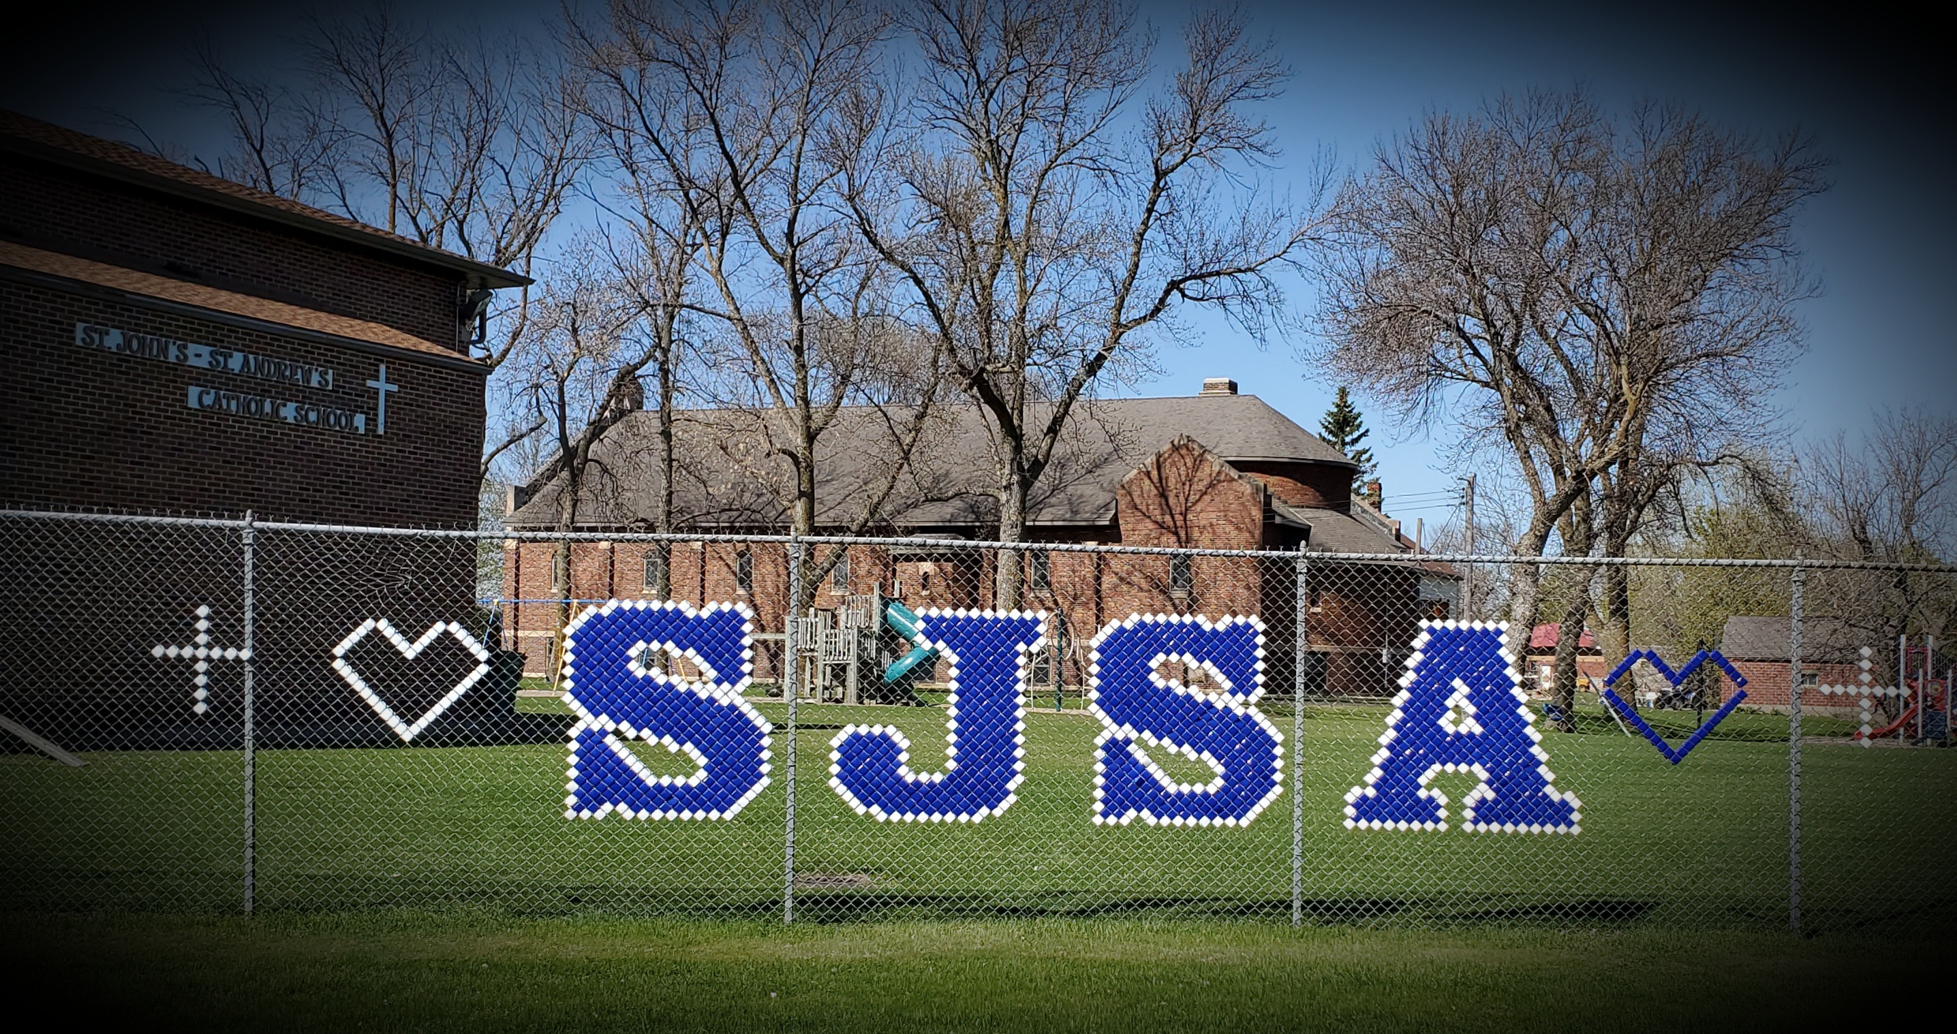

St. John’s - St. Andrew’s Catholic School
121 2nd Ave N. P.O. Box 120
Greenwald, MN 56335
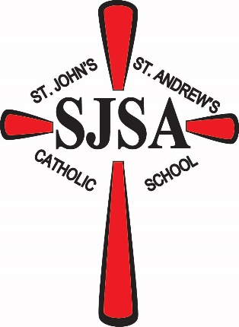
www.sjsaschool.org
Check us out on facebook at:
St. John’s – St. Andrew’s School

