February 28, 2020
Dear SJSA Families,
Thank you so much for all the time and effort you put in to the Steak and Wine Dinner and Auction! I’ve heard from many people that they loved the variety of auctions items and the fun atmosphere. I do not have final numbers yet, but as soon as I do, I’ll let you know. Next year will be the 30th anniversary of Steak & Wine, so start thinking of some special ways we can celebrate!
Lent – The student council Lenten Service Project is collecting personal items for the Melrose Area Food Shelf. They are in need of toothbrushes, toothpaste, shampoo, conditioner, and laundry detergent. We will collect items March 2nd - 31st. We will have collection boxes in the back of St. Andrew’s and St. John’s Churches. Items can also be brought to school.
Parent Teacher conferences are Thursday, March 12th from 2:30 pm -7:00 pm. A sign-up sheet is included in your parent envelope. There is no school at SJSA on Friday, March 13th.
The last day of the quarter is March 26th. No School March 27th. We will have a teacher workshop. Report cards will go home the week of March 30th.
SJSA Speech Festival for grades 3-6 will be held on Thursday, March 26th at 9:00 am in the school basement. Winners from grades 4-6 will be chosen to represent SJSA at the Area Speech Festival on Tuesday, April 21st at 4:00 pm at St. Mary’s in Melrose.
SJSA Podcast, The Eagle Update, is available on Apple Podcasts, Google Podcasts, Spotify, and Tuneln+Alexa. You can subscribe to the podcast to be notified of new episodes or have them automatically downloaded. The podcast can also be found on the school website at www.sjsaschool.org.
Harry’s Pizza Sale – Our third and final pizza sale of the school year is February 28th – March 11th. Pizza pick-up is Saturday, March 21st. Our pizza sale goal for the year is $8,000. Our first two sales brought in $5,533.50 so we need $2,666.50 to make our goal. If you are able to help out and sell pizzas, thank you!
Scrip – We have a variety of local and national Scrip gift cards. A list of what we have on hand is in today’s envelope.
Stations of the Cross/Confession – The students will lead Stations of the Cross on Friday, March 6th and Friday, March 20th at 2:00 pm at St. Andrew’s Church in Greenwald and on Friday, April 3rd at 2:00 pm at St. John’s Church in Meire Grove. Students in grades 2-6 will go to confession on Friday, March 20th at 12:45 pm.
I wish you a blessed start to Lent,
Mrs. Mary Miller
DATES TO REMEMBER
Feb. 28th-Harry’s Pizza sale begins
March 1st-Catholic United Financial raffle ends
March 2nd-Catholic United Financial raffle tickets returned to school (all sold & unsold)
March 11th-Pizza sale ends
March 12th-Parent/teacher conferences 2:30-7:00
March 12th-Catholic United Financial raffle drawing
March 13th-No School
March 17th-School Board meeting at 7:30 in school basement
March 21st-Pizza pick-up 9:00-10:00am
March 26th-End of 3rd quarter
March 26th-Speech competition 9:00am at school, all are welcome
March 27th-No school-teacher workshop
March 30th-Kindergarten round-up
March 30th-Walk In the Park Day
April 1st-Preschool Open House 3:00-6:00
5TH & 6TH GRADE NEWS
Matthew and Logan F. will be hosts for the March episode of The Eagle Update podcast. The episode will be posted online soon.
Our curriculum focuses for the past month were:
Math: 5th: Chapters 6 & 8 (Fractions & Decimals: Addition & Subtraction)
6th: Chapters 7 & 8 (Fractions & Probability)
Science: Life Science: Chapter 1 - Cells and Kingdoms
Social Studies: Chapters 6 & 7 - The Middle Colonies & The Southern Colonies (1647—1740s)
Language Arts: Writing Focus: Argument
Religion: Chapters 5-7 Mrs. Kasper
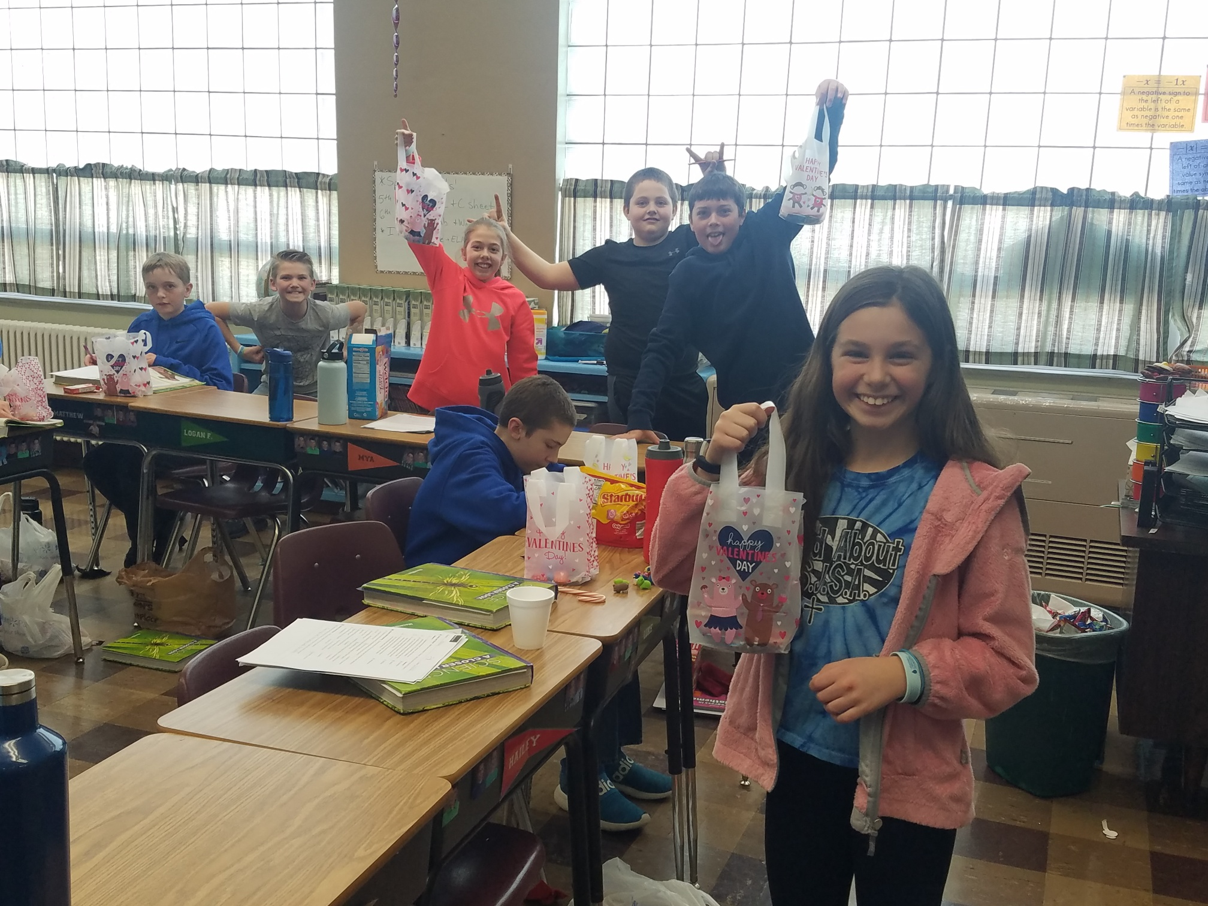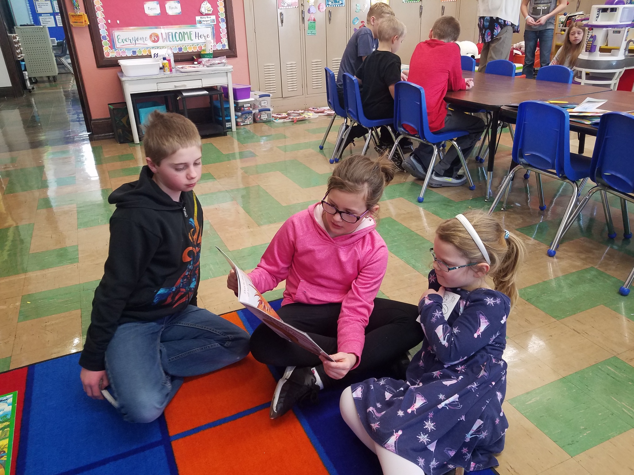
3RD & 4TH GRADE NEWS
Hello Parents,
We have started to practice our stories or poems for the speech festival. The 3rd graders are not going on to the speech festival but are doing speeches at our school. Two of the fourth graders will be going on to the speech festival at St. Mary’s School in Melrose. There will be one alternate selected in case one of the other two can’t attend.
We have also started to practice for the Passion Play. We will be going over to church to practice throughout March.
For lent the students are doing a Lenten Cross which gets colored in if they remember to follow through with giving up something or doing something special during Lent. Our class will be in charge of Stations of the Cross on April 3rd at 2:00 in Meire Grove. Come and join us if you can.
Don’t forget to sign up for conferences!
If you have any questions or concerns please let me know.
~ Mrs. Schmiesing
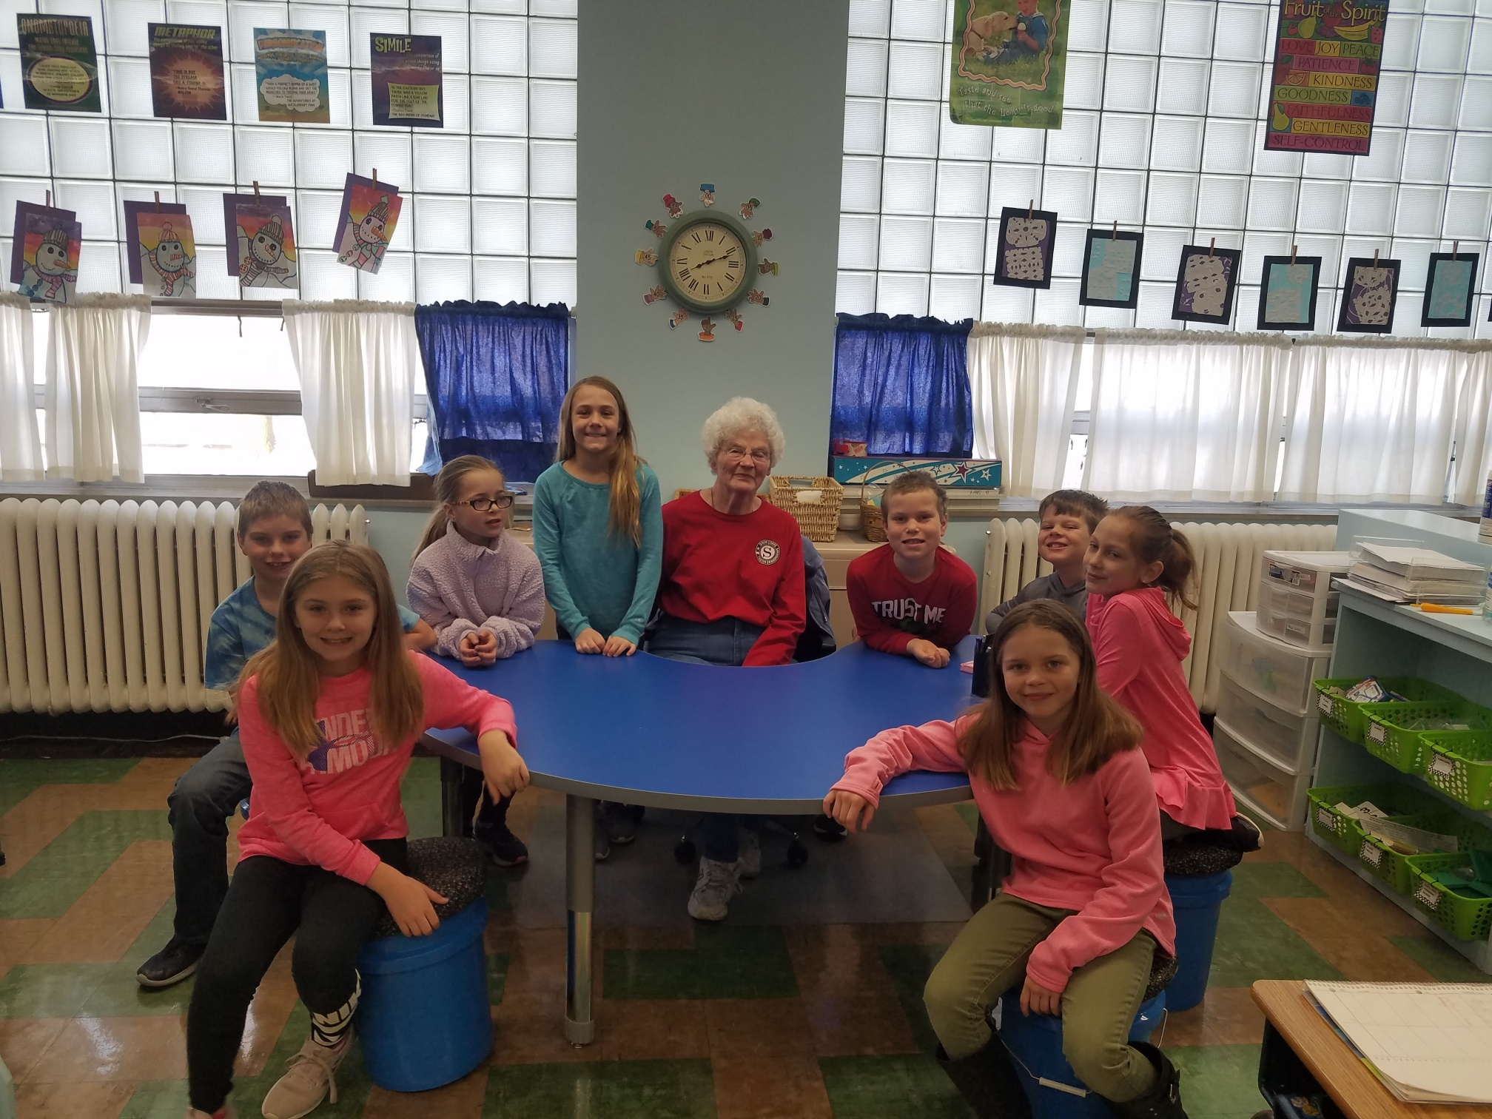
1ST & 2ND GRADE NEWS
Reading: First grade started learning about vowel teams and other ways that vowels "say their names". Second graders learned a lot about the "Bossy R" and how it changes the vowel sounds around it.
Math: First grade has reviewed adding to 20 and subtracting from 20. Second grade learned about the hundreds place value and how to add three-digit numbers.
Religion: First grade is learning about the Holy Trinity. Second graders are preparing for First Communion.
Science: We finished our unit on weather and seasons. Our next chapter is all about space.
Mr. H

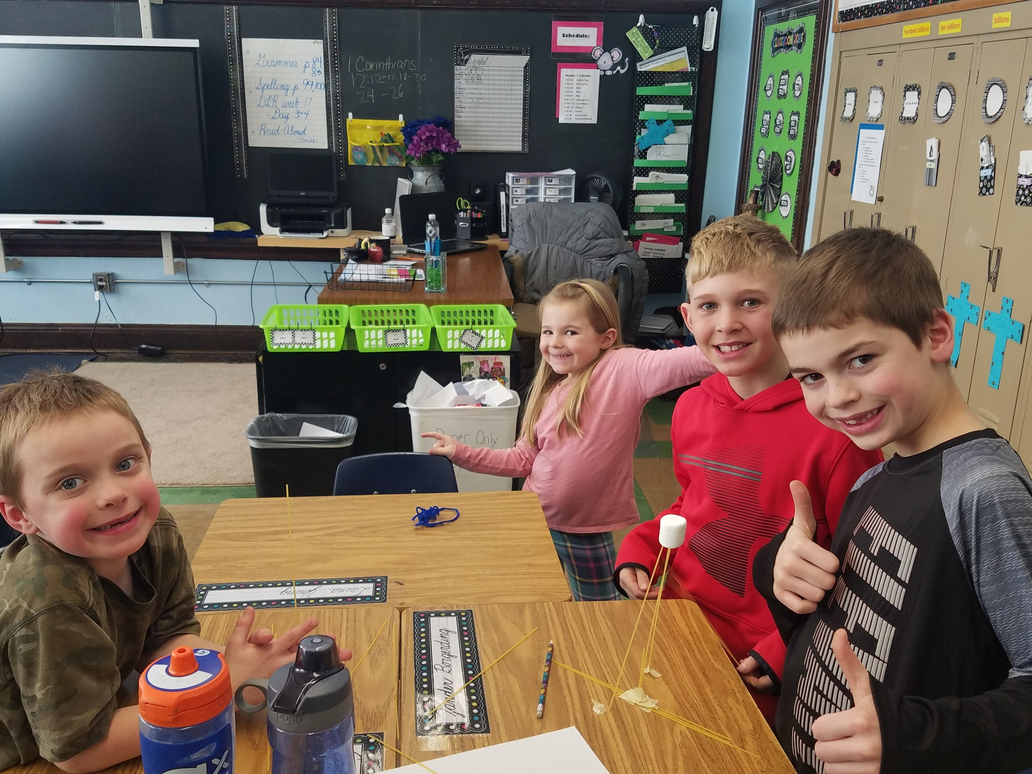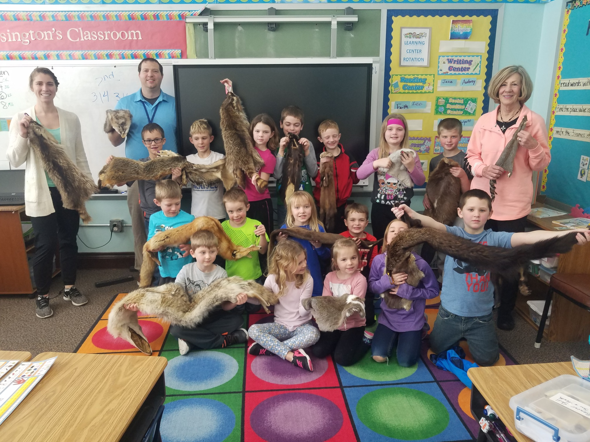
KINDERGARTEN NEWS
Kindergarten continues to work hard.
In language arts, they've been learning to sound words out and blend sounds together.
In math, they've practiced working with two-digit numbers and number sequence, they've also started learning about money.
We've been focused on physical science lately.
In social studies, we've been discussing American holidays.
Ms. Viere

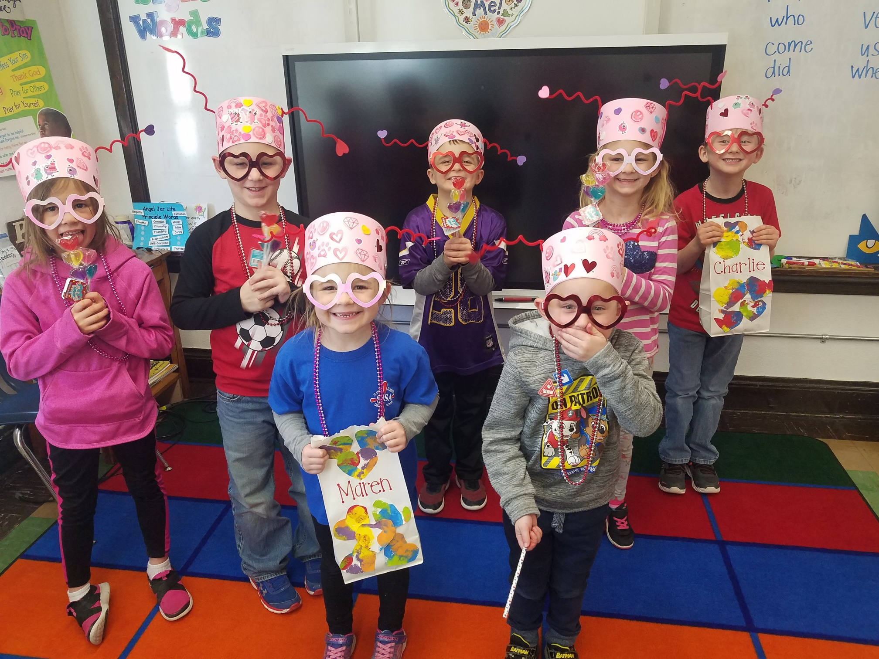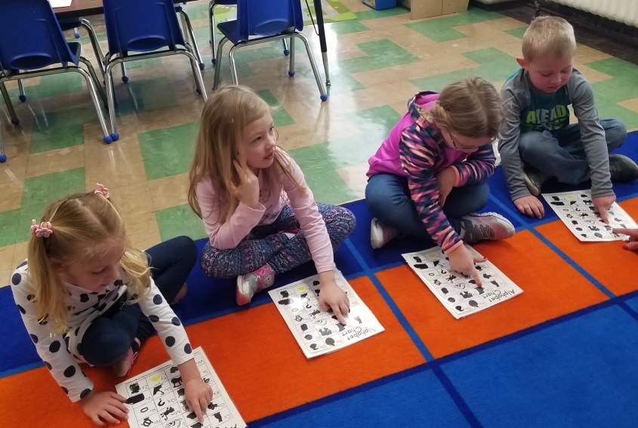
PRESCHOOL NEWS
February is the month of LOVE. In pre-school the boys and girls learned to love God and each other. Jesus teaches us about love and they learned to “Sprinkle Kindness” everywhere they go. For the letter Dd they made dancing donuts with lots of sprinkles. They exchanged Valentine cards wearing visors for the letter Vv and showed their love for each other.
They looked at a large quilt for the letter Qq and examined it to find same and different parts on it. For the letter Ll they made leprechauns. The leprechauns are marching into Spring with a bright smile on their face. You will find thim on the Pre-school/Kindergarten bulletin board in the hall. The students had so much fun dancing like leprechauns, counting them up to ten, and putting the numbers on them in numerical order.
It’s so great that the boys and girls read 4 shared reading books this month, Dd for Ducks, Vv for Van, Qq for Queen, and Ll for Leaf. They are learning to recognize some words and some of them can write a sentence.
We are all looking forward to the month of March and are wondering if it will come in like a lion or a lamb.
Mrs. Ingold

