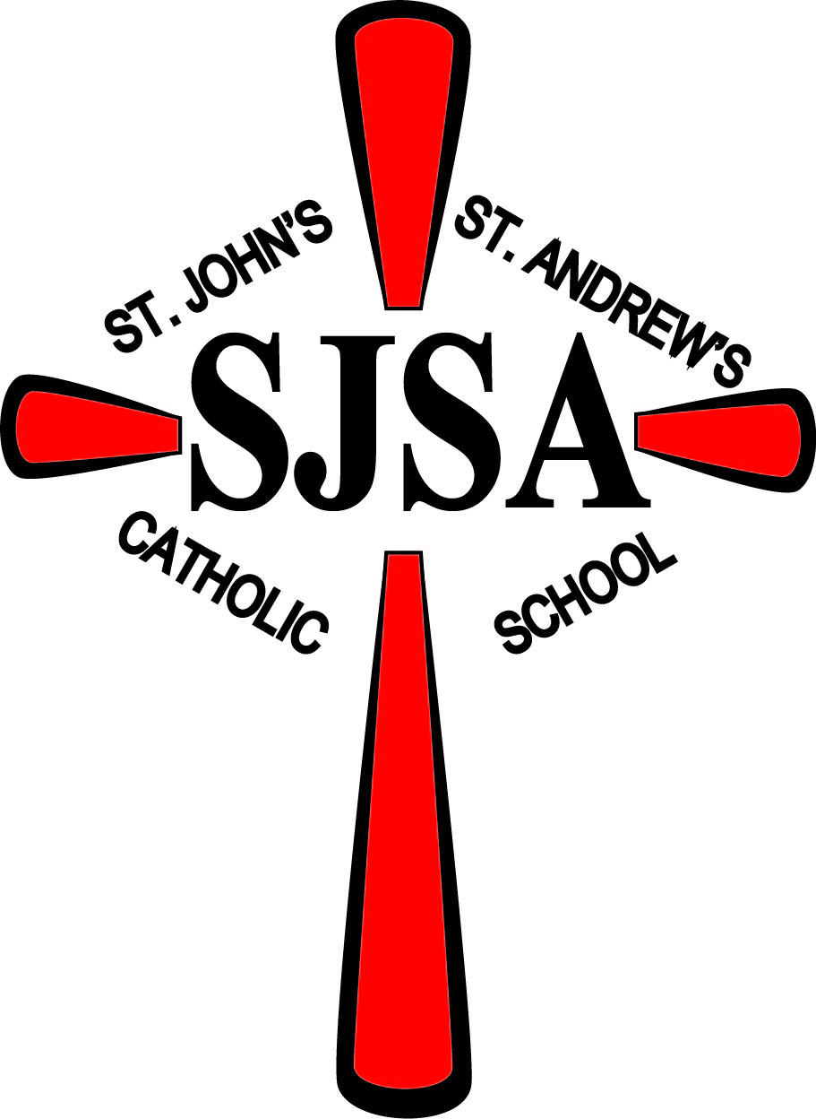 September 3, 2020
Hello SJSA Families,
I hope this finds you all doing well. It is so great to have the children back in school! They have done a wonderful job this week adapting to the COVID-19 safety protocol. The teachers and I are so proud of them. They are truly demonstrating a real caring for their neighbors. Thank you for all you have done as parents to prepare them for the school year.
Congratulations to Jackson Gilk, Leo Kasper, Faith Meyer, Aubrey Stepan, Jake Worms, and Shane Zimmer on receiving their First Holy Communion on August 29th.
Student Weekly Mass – Due to COVID-19 restrictions, we will have one student per Mass do the reading and response. The priest will read the petitions.
Safety Drills – We will have a fire drill Tuesday, September 8th, tornado drill Thursday, September 10th and ALICE (safety lockdown drill) Tuesday, September 15th. The drills are to prepare the children in the unlikely event of an emergency.
Harry’s Pizza Sale – Please turn in your order sheets by Thursday, September 24th. Pizza pick-up is Saturday, October 3rd from 9:00-10:00 am. Thank you for your support of this fundraiser.
Blessing of the Animals – We will have our annual Blessing of the Animals in honor of The Feast of St. Francis on Friday, October 2nd at 2:00 pm. The blessing will take place on the lawn between the school and church. All animals, big and small are welcome! Pray for sunshine! If it rains, we will reschedule.
Work-a-thon – Thank you for sending in addresses for the work-a-thon on Friday, October 9th. Our fundraising goal is $15,000. The children have been busy writing and signing letters. The children will stay in Greenwald to rake and pick up trash. Again, please pray for favorable weather. A Mass will be offered for all who support our Work-a-thon.
Prayer Wall- The students will offer prayers each school day and tie ribbons on the prayer wall. If any of you have someone or something, you would like us at SJSA to pray for, please send your requests with your child.
No school at SJSA on Friday, September 4th and Monday, September 7th. Have a safe and fun Labor Day weekend.
Blessings to you,
Mary Miller
Love the Lord your God with all your heart, with all your soul, and with all your mind. This is the greatest and most important commandment. The second most important commandment is like it: Love your neighbor as you love yourself. Matthew 22:38-39

DATES TO REMEMBER
Sept 4th-No School
Sept. 7th-No School Labor Day
Oct. 2nd-Blessing of the Animals on the school grounds at 2:00
Oct. 9th-School pictures in the morning
Oct. 9th-Workathon in the afternoon
5TH & 6TH GRADE NEWS
Our first week was unique this year, but the 5th and 6th graders have adapted well to the new procedures. They have been especially cooperative about wearing their masks. I have had to give them a few reminders to space themselves apart, but overall, they are doing well with everything.
We spent time this week doing some reviews of content and topics from last year. We will continue to review next week and start taking a few assessments (including FAST) in the upcoming weeks to determine where each student is starting the year in terms of knowledge and ability.
The year is off to a great start! I hope you all have a wonderful Labor Day weekend.
Mrs. Kasper

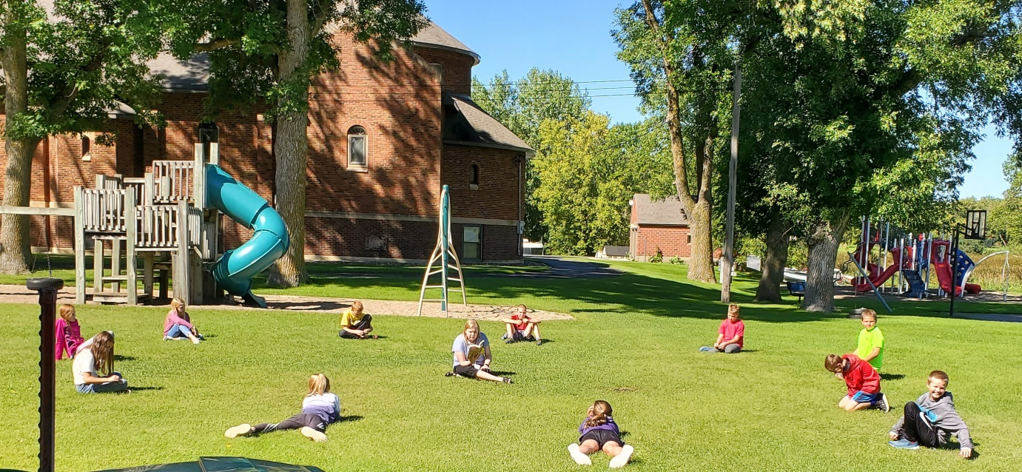
3RD & 4TH GRADE NEWS
Hello Parents,
It was so nice being able to teach your children in person. Hopefully we can do this all year.
The first couple of days back are filled with lots of new things. We are getting used to wearing masks. We are learning how to social distance (although this one is tougher to remember), and of course washing our hands really well.
We have also managed to do some math, spelling, stories, grammar, DLR (Daily Language Review), Workathon letters, and getting used to the mini chrome books, and chrome laptops. We are teaching them how to find math videos on the website for now and how to use the videos. We have practiced using the i-pads for extra math practice, we have touched on bus safety, and much more.
By the end of next week, I am confident we will get into our school routine.
If you have any questions or concerns, please contact me at school 987-3133 or write a note in the planner or email me at sjsaschmiesinga@gmail.com.
~Mrs. A. Schmiesing

1ST & 2ND GRADE NEWS
Hello,

We are off to a great start!
The children have adapted really well to wearing masks, washing their hands, and staying to the right while walking throughout the school. We are so excited to have them back!
Mr. H

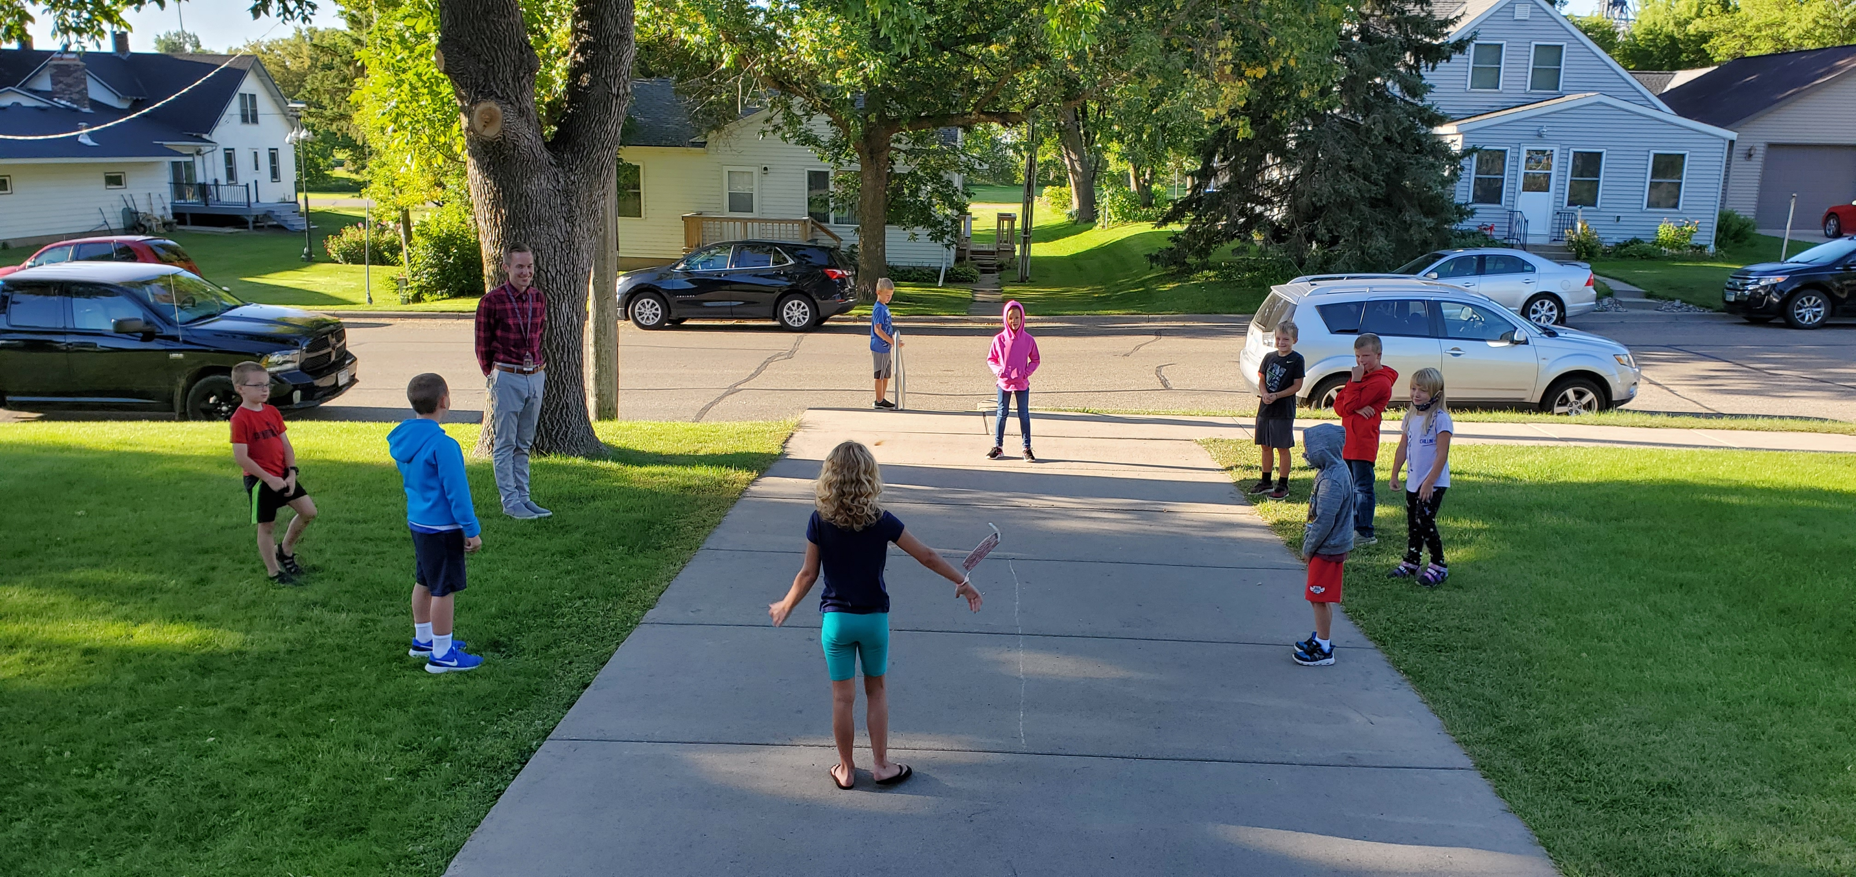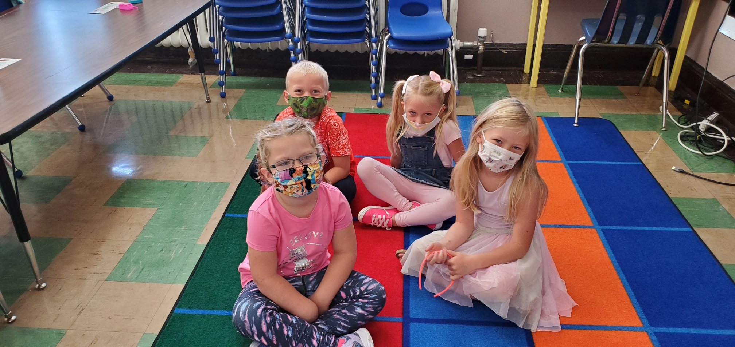

KINDERGARTEN NEWS
Kindergarten has had a great first week of school! They were shy on the first day, but they warmed up to our routine quickly, and now they constantly share what parts of the day they are looking forward to when they arrive.

In Math, we're beginning our geometry unit. We've started working on sight words and the letter M in Language Arts, and we will continue to expand on these in the next few weeks. Our class has been doing great at writing their daily journal pages, and they love doing art projects. We also started discussing citizenship in Social Studies.
Ms. Viere

